DB ASSIGNMENT#2
22k-4042 Areeb Hussain

QUESTION 1
PART A
Film | Actor | ProductionCompany
- FilmID (PK)  - Title  - Budget  - ReleaseDate  - DirectorName | - ActorID (PK)  - Name  - PhoneNumber | - CompanyID (PK)  - Name

PART B
Main Relationships and Cardinality
- Film – Actor (Casting)
  - Relationship: A Film casts many Actors; an Actor can act in many Films.
  - Cardinality: M:N
- Film – ProductionCompany (Funding)
  - Relationship: A Film is funded by one or more Production Companies, a Production Company can fund many Films.
  - Cardinality: M:N
Note: Film and Director will not have any relationship defined as Director is not an entity in this scenario, it is an attribute.

PART C
- Associative Entity Name: Casting
- Attributes:
  - CastingID (PK) – Unique identifier for each casting record
  - FilmID (FK) – References the Film being cast
  - ActorID (FK) – References the Actor being cast
  - CharacterName – The role the Actor plays in the Film
Note: CastingID is the primary key, while FilmID and ActorID are foreign keys. This structure ensures each casting record is unique and allows easy extension.

PART D
In this scenario, the director is only tracked as a name in the Film and no additional details about directors are required, hence it is not required as a separate entity. Creating a separate Director entity would add unnecessary complexity (extra table, foreign key, joins) without providing any additional benefit, since there’s no further information to store or manage about directors.

QUESTION 2
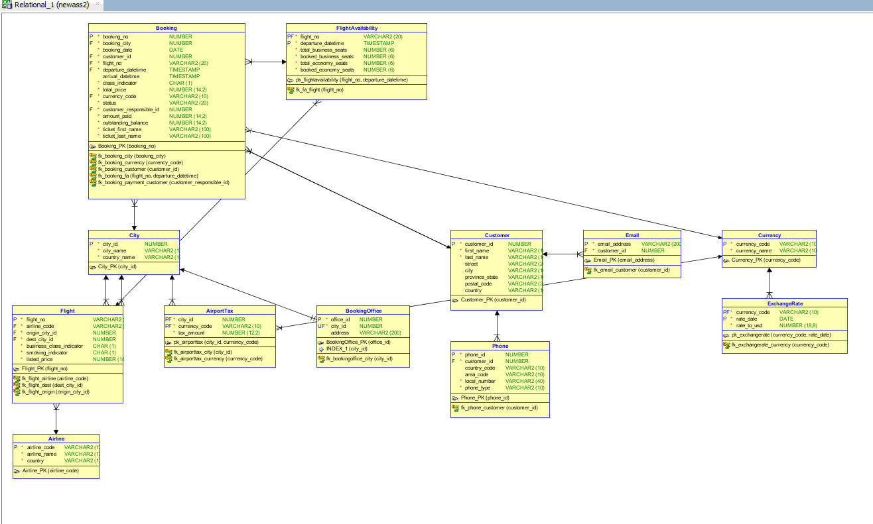

QUESTION 3
PART A
1. Insertion Anomaly
- Reasoning: School information (schoolID, schoolName, schoolCity) is stored together with teacher and hours info. You cannot add a new school unless at least one teacher works there.
- Example: To add a new school S200 Blue School London, a teacher must already be assigned; otherwise, school info cannot be stored in the table.

2. Deletion Anomaly
- Reasoning: School information is repeated in every row where a teacher works. Deleting a teacher record may remove the only row containing the school’s information.
- Example: If we delete Lewis H’s record for S114 Green School, the school information for Green School in Birmingham would be lost.

3. Update Anomaly
- Reasoning: School info is duplicated across multiple rows. Changing the school’s city requires updating all rows; missing any row leads to inconsistent data.
- Example: If Park School moves from Manchester to Liverpool, all rows with S301 must be updated. If one row is missed, the table shows conflicting cities for the same school.

PART B
Functional Dependencies (FDs)
- NIN → tName (NIN uniquely identifies the teacher’s name)
- schoolID → {schoolName, schoolCity} (schoolID uniquely identifies school info)
- {NIN, contractNo, schoolID} → hours (a teacher works certain hours per contract at a school)

Decompose into 1NF
- Table is already in 1NF (all attributes atomic).

Decompose into 2NF
Partial dependencies:
- NIN → tName
- schoolID → schoolName, schoolCity
Decomposing into separate tables:

Teacher Table:
NIN | tName
2103 | Brown A
2198 | Khan R
2205 | Lewis H

School Table
schoolID | schoolName | schoolCity
S301 | Park School | Manchester
S114 | Green School | Birmingham

Work Table:
NIN | contractNo | schoolID | hours
2103 | T9001 | S301 | 10
2198 | T9001 | S301 | 18
2205 | T9001 | S114 | 20
2103 | T9001 | S114 | 12

Decompose into 3NF
- All tables are now in 3NF because:
  - No non-prime attribute depends on another non-prime attribute.
  - Each non-key attribute is fully functionally dependent on the primary key.

Final 3NF Tables:
- Teacher (NIN → tName)
- School (schoolID → schoolName, schoolCity)
- Work (NIN + contractNo + schoolID → hours)

QUESTION 4
PART A
PK: (FilmID, ActorID)

PART B
Table is in 1NF (all attributes atomic).
For 2NF:
- 2NF requires no partial dependency on part of a composite PK.
- Partial dependencies exist:
  - FilmID → , AgentID (depends only on part of PK)
  - Violation: 2NF, because non-key attributes depend on part of the composite key, not the whole key.
Example: FilmTitle depends only on FilmID, not on ActorID.

PART C
Removing partial dependencies on the composite PK.
- Film Table
  - Attributes: FilmID (PK), FilmTitle, DirectorName
  - FD Removed: FilmID → FilmTitle, DirectorName
- Actor Table
  - Attributes: ActorID (PK), ActorName, AgentID
  - FD Removed: ActorID → ActorName, AgentID
- Film_Casting Table (2NF)
  - Attributes: FilmID (FK), ActorID (FK)
  - FD Remaining: FilmID + ActorID → (all other attributes removed to separate tables)
- Agent Table (optional at 2NF stage, can be included later for 3NF)
  - Could remain in Actor table at 2NF; fully normalized later.
PART D
Removing transitive dependencies (non-key attributes depending on other non-key attributes).
- Film Table (already in 3NF)
  - Attributes: FilmID (PK), FilmTitle, DirectorName
- Actor Table
  - Attributes: ActorID (PK), ActorName, AgentID (FK)
- Agent Table
  - Attributes: AgentID (PK), AgentPhone
- Casting Table
  - Attributes: FilmID (FK), ActorID (FK)
All transitive dependencies are removed: AgentPhone depends only on AgentID, not on ActorID or FilmID.

PART E
Data Redundancy Anomaly
- Type of anomaly: Update Anomaly
Example:
- ActorID = 101 has AgentID = A10 with phone 555-1234.
- If Actor 101 acts in 3 films, AgentPhone appears 3 times. Changing the phone requires updating all 3 rows; missing one causes inconsistent data.

QUESTION 5
PART A
Attributes from the form:
- StudentID, LastName, FirstName, Address
- CourseID, CourseName, Credits, InstructorName
- EnrollmentDate
Assumptions:
- Each StudentID uniquely identifies a student.
- Each CourseID uniquely identifies a course.
- Students can enroll in multiple courses; courses can have multiple students.
- InstructorName depends on CourseID (each course has one instructor).
- EnrollmentDate depends on StudentID + CourseID (date student enrolled in that course).
Functional Dependencies:
- StudentID → LastName, FirstName, Address
- CourseID → CourseName, Credits, InstructorName
- (StudentID, CourseID) → EnrollmentDate

PART B
1NF:
- Table is already in 1NF (atomic values, no repeating groups).
2NF:
- Composite key: (StudentID, CourseID) in the enrollment table
- Partial dependencies exist:
  - StudentID → LastName, FirstName, Address
  - CourseID → CourseName, Credits, InstructorName
- Removing partial dependencies by creating separate tables:

Students Table:
StudentID (PK) | LastName | FirstName | Address
S1001 | Smith | James | 123 Oak Street

Course Table:
CourseID (PK) | CourseName | Credits | InstructorName
CS101 | Introduction to Computer Science | 3 | Dr. Baker
MA202 | Calculus II | 4 | Dr. Johnson
PH301 | Physics | 3 | Dr. Lee

Enrolment Table:
StudentID (FK) | CourseID (FK) | EnrollmentDate
S1001 | CS101 | 15/01/2024
S1001 | MA202 | 15/01/2024
S1001 | PH301 | 15/01/2024

3NF:
All tables are already in 3NF because:
- Non-key attributes are fully functionally dependent on the PK of their table.
- No transitive dependencies exist.

PART C
Table | Primary Key (PK) | Alternate Key(s) | Foreign Key(s)
Student | StudentID | None | None
Course | CourseID | CourseName (assumed unique) | None
Enrollment | (StudentID, CourseID) | None | StudentID → Student, CourseID → Course

